|  |  |
| --- | --- |
| EGC_Black | **MATHEMATICS:SPECIALIST 1 & 2**  **SEMESTER 2 2016**  **TEST 5**  **Calculator Free** |

Time Allowed: 20 minutes Total Marks: 15

**1.** [3, 3 marks]

(a) Sketch $y=\sec{\frac{1}{2}x}$ over the domain $-2π≤x≤2π$

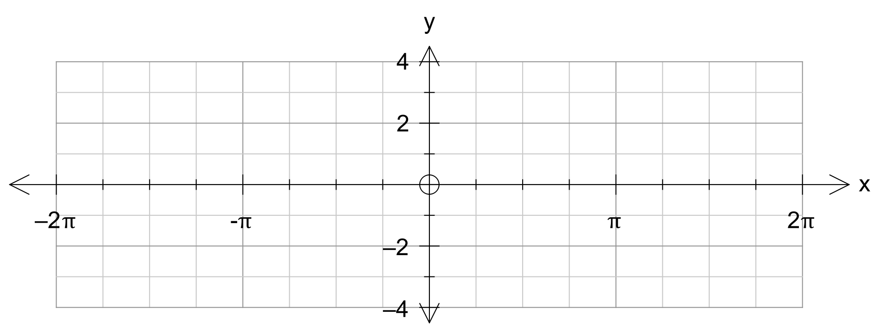

(b) Sketch $y=2\operatorname{cosec}{x}$ over the domain $0≤x≤2π$

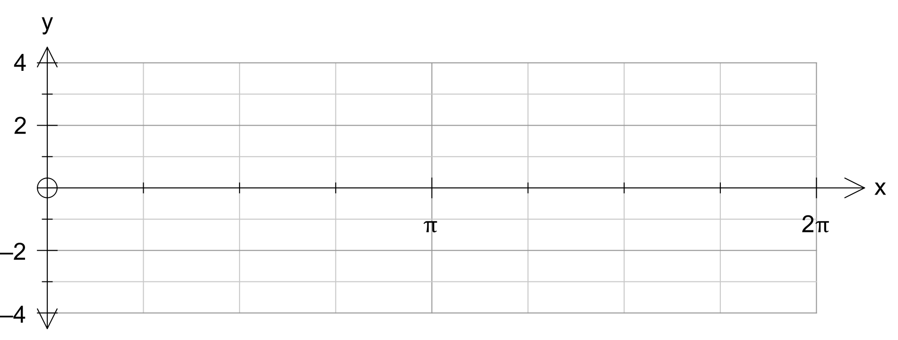

**2.** [2, 2 marks]

Find all solutions to the following equations for $x$ in degrees

(a) $\sin{x}=0.5$

(b) $\cot{x}=\sqrt{3}$

**3.** [5 marks]

Prove by contradiction: The equation $4x^{2}-y^{2}=1$ has no integer solutions for x and y.

|  |  |
| --- | --- |
| EGC_Black | **MATHEMATICS:SPECIALIST 1 & 2**  **SEMESTER 2 2016**  **TEST 5**  **Calculator Assumed** |

Time Allowed: 40 minutes Total Marks: 34

**4.** [2, 3, 1, 2 marks]

The height of the tide above mean sea level at a certain port has been modelled by the equation

$h\left(t\right)=4\sin{\frac{π(t+1)}{6}}$

where *t* is the number of hours after midnight on a particular day.

(a) Neatly sketch the graph for $h\left(t\right)=4\sin{\frac{π(t+1)}{6}}$ for $0≤t≤24$

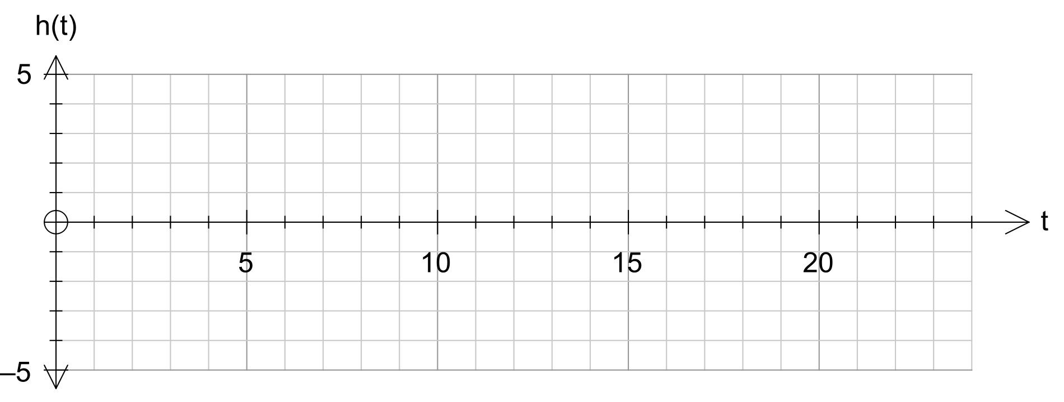

(b) When was the high tide? What is its height above mean sea level at this time?

(c) What was the height of the tide at 8 pm?

(d) A ship can only enter port when there is a depth of 3 metres of water above low tide. Between what times could a ship enter or leave port? Give answers to nearest 5 minutes.

**5.** [4, 4, 3 marks]

(a) Prove that 3 more than the square of an odd number is always divisible by 4.

(b) Consider three consecutive numbers. Prove that the sum of the cube of the smallest number, the square of the middle number, and the largest number will always be a multiple of the middle number.

(c) Express $0.14527527527…$ as a fraction. Show full working.

**6.** [3, 2, 4 marks]

Determine the equation of the following graphs”

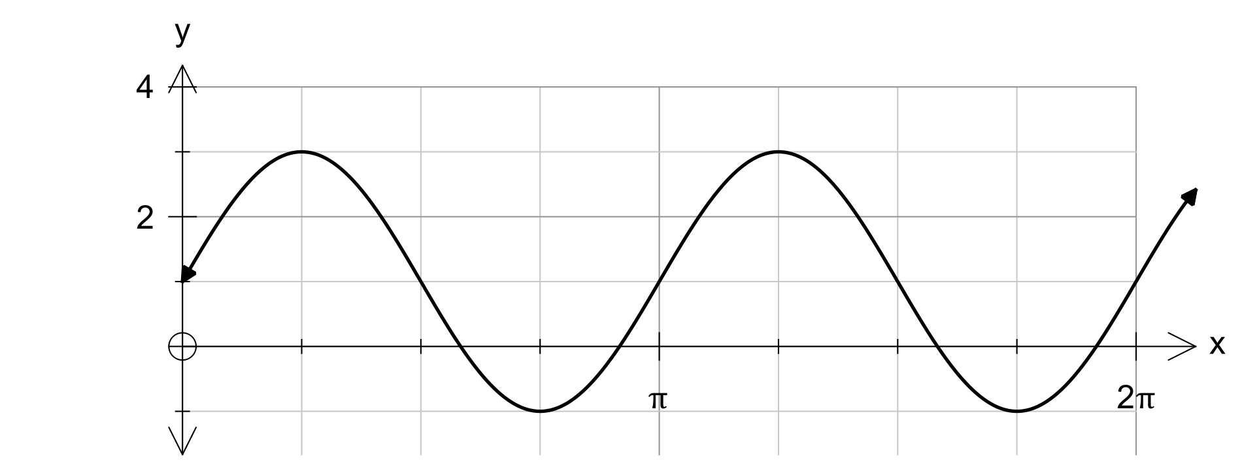(a) y =

(b) y =

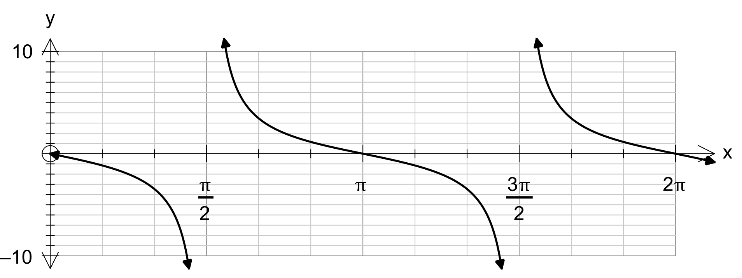

(c) y =

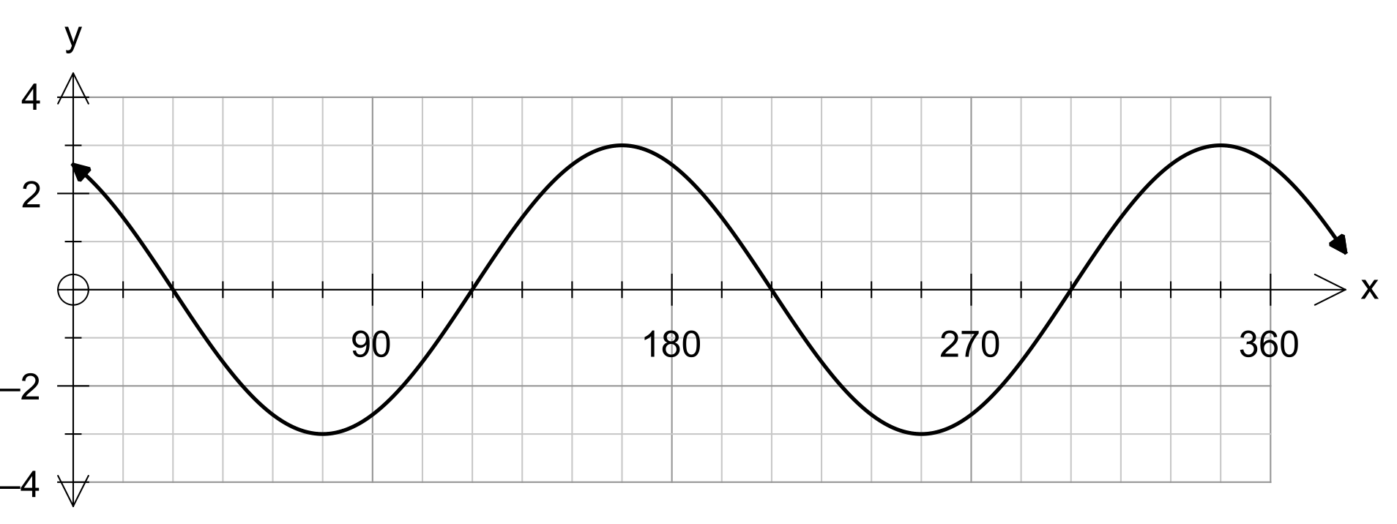

**7.** [2, 3, 1 marks]

For the sequence **5**, **12**, **19**, **26**, **. . .** ,

a) Find an expression (in simplest form) for **Tn ,** the nth term of this sequence.

b) Prove that the sum of any two consecutive terms of this sequence is always odd.

b) Use a counter example to disprove that “The sum of any three terms of this sequence is always even.”